Name

Mathematics Stage 4
Percentages Problems

Book 10 | Solve problems that involve the use of percentages | Version: 260409  Feedback:  https://MrDingMaths.com
Contents
Syllabus Content 2
Repeated Percentage Change 3
The Unitary Method for Percentages 13
Unitary Method for Reverse Percentage Problems 19
Unitary Method for Financial Problems 23
Goods and Services Tax (GST) 28
Mixed Practice 36
Equations Method 47

Syllabus Content
MA4-FRC-C-01 represents and operates with fractions, decimals and percentages to solve problems
Solve problems that involve the use of percentages
- Apply knowledge of percentages to calculate quantities in various contexts
- Apply knowledge of percentage increases and decreases to solve problems in various contexts
- Solve real-life problems involving percentages using the unitary method or other techniques
- Solve financial problems involving percentages, specifically considering GST, profit and loss

Repeated Percentage Change

- Review
- Increase and decrease by a percentage
- Increase 50 by 40% | - Decrease 85 by 25%
- Decrease 80 by 48% | - Increase 48 by 29%

- Convert multiplier to a percentage
- $×1.4$ means …………………  by ………% | - $×1.78$ means …………………  by ………%
- $×0.8$ means …………………  by ………% | - $×.55$ means …………………  by ………%

- Repeated Percentage Change
When applying many percentage changes one after the other, we multiply.
We do NOT add or subtract the percentages.
- Convert each percentage to a multiplier.
- Multiply the multipliers together. This is the overall percentage change.
- Multiply by the original amount.

- Example Calculate repeated percentage change.
Increase $1000 by 30%, then increase the result by another 20%.
1. $\$1000×1.3×1.2$  2. $=\$1000×1.56$  3. $=\$1560$ | The multiplier for 30% increase is $×$ ……  The multiplier for 20% increase is $×$ ……  We multiply | add the multipliers.  The combined multiplier is $×1.56,$ so the overall increase is ……%

- Guided Practice
- Increase $80 by 20%, then increase the result by 40% | - Decrease $200 by 10%, then decrease the result by another 15%
- Increase $150 by 30%, then decrease the result by 30% | - Increase $500 by 100%, then decrease the result by 100%.

- Key Ideas
- When applying repeated percentage changes, we …………… the changes.
- We do NOT …………… or ……………… the percentages.
- To find the overall percentage change, convert the combined multiplier to a percentage and subtract …………%

- Investigation Repeated percentage change
A rare stuffed toy was bought for $100.
$100

After a year, its value increased by 50%.
$………
$100

Its new value is: ……………

After another year, its value increased by another 50%.
$150
$………

Its new value is: …………


two 50% increases mean an increase of 50 + 50 = 100%.
So, the value doubles.

Explain why she is incorrect.
Percentages apply to the current value at each step, not the original.
The second increase is applied to a ………… value.
Each increase gets larger and larger. The overall change is $1.5×1.5=$ ……… the original.
A rare stuffed toy was bought for $100.
$100

After a year, its value decreased by 50%.
$………

Its new value is: ……………

After another year, its value decreased by another 50%.
$……

Its new value is: …………

two 50% decreases mean 50 + 50 = 100% decrease.
So, the value is now 0.

Explain why she is incorrect.
Percentages apply to the ……………… value at each step, not the original.
The second increase is applied to a ………… value.
Each decrease gets …………… and …………… The overall change is $0.5×0.5=$ ………

Foundation

- Increase $120 by 15%,  then increase the result by 15%  $\$120×1.15×1.15=$  $158.70 | - Decrease $120 by 15%,  then decrease the result by 15%  $86.70
- Decrease $120 by 15%,  then increase the result by 15%  $117.30 | - Increase $150 by 10%,  then increase the result by 10%  $181.50
- Decrease $150 by 10%,  then decrease the result by 10%  $121.50 | - Increase $150 by 10%,  then decrease the result by 10%  $148.50
- Decrease $150 by 10%,  then increase the result by 10%  $148.50 | - Decrease $150 by 10%,  then increase the result by 15%  $155.25
- A television costs $500. Its price is increased by 10%.
  - What is its new price?
$550
  - After a year its price is increased by another 10%. What is its price now?
$605
  - Find 120% of 500
$600
  - Is increasing by 10% then 10% again the same as increasing by 20%?
no

- A television costs $500. Its price is decreased by 10%.
  - What is its new price?
$450
  - After a year its price is decreased by another 10%. What is its price now?
$405
  - Find 80% of 500
$400
  - Is decreasing by 10% then 10% again the same as decreasing by 20%?
No

- A television costs $500. Its price is increased by 5%.
  - What is its new price?
$525
  - After a year its price is decreased by 5%. What is its price now?
$498.75
  - Does increasing by 5% then decreasing by 5% keep the price the same?
no

- In a sale, the prices of all items in a shop are reduced by 10%.
For a promotion, the shop is offering an extra 20% off sale prices.
Work out the price of a handbag that cost $60 before the sale.

$43.20
Is this the same as 30% off?

30% off is $42. No.

- Ali buys a car for $18000.
The value of the car depreciates by 16% in the first year and 12% each year after the first.
Work out the value of the car at the end of 3 years.

$11708.93
- Abdullah invested $2000 in shares. In March, the value of his shares increased by 4%.
In April, the value of his shares decreased by 6%.
Work out the value of Abdullah's shares at the start of May.

$1955.20
- Identify what is incorrect about this statement:
“$400 to $800 is an increase of 100%, so $800 to $400 is a decrease of 100%.”

$800 to $400 is a decrease of 50%.

Development
- If an amount is increased by the same percentage each time, powers can be used. For example: 50 increased by 12% three times would be:
$50×1.12×1.12×1.12$
$=50×{\left(1.12\right)}^{3}$
$=70.25$ (2 d.p.)
Use a similar technique to find the final value in these situations. Round to 2 decimal places.
  - The mass of a rat initially at 60 grams grows at a rate of 10% every month for 3 months.

79.86 g
  - The cost of a new car initially at $80 000 increases by 5% every year for 4 years.

$97240.50
  - The value of a house initially at $380 000 decreases by 4% per year for 7 years.

$285 550.04
  - The length of a pencil initially at 16 cm decreases through being sharpened by 15% every week for 5 weeks.

7.10 cm
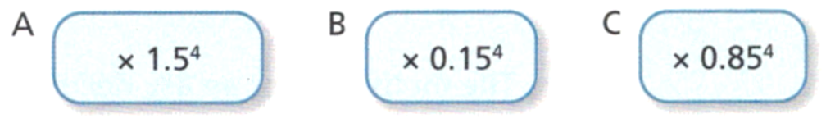
- Which of these calculations would give the result of a 15% decrease, repeated 4 times?

- There are 300 cells in a Petri dish. The number of cells increases by 6% every hour.
Work out the number of cells in the dish after these times, answer to the nearest whole.
- 1 hour  318 cells | - 6 hours  426 cells | - 72 hours  19913 cells

- The value of a car depreciates by 12% per year. Faith's car cost $55 000 when new.
Work out the value of the car after.
- 1 year  $48 400 | - 5 years  $29 025.26 | - 10 years  $15317.55

Worked Solution | Explanation
A shopkeeper increases prices in his store by 30%.  A year later, he increases the prices by a further 10%.  What is the overall percentage increase?  $1.3×1.1=1.43$  Overall percentage increase of 43%. | Why did we do $1.3×1.1$?  The multiplier for ……% increase is $×$1.3  The multiplier for ……% increase is $×$1.1  The result of 1.43 means the new price is 143% of the ………………… price.  Where did we get 43% increase from?  $143\%-$ ………% $=43\%$

- Calculate the overall percentage change if:
- 10% increase is followed by another  10% increase.  21% increase | - 20% increase is followed by another  5% increase.  26% increase
- 35% increase is followed by another  10% increase.  48.5% increase | - 33% increase is followed by another  15% increase.  52.95% increase

Worked Solution | Explanation
In a sale, all items are reduced by 30%. Shirley has a membership card that takes a further 10% off the sale price.  What is the overall percentage discount?  $0.7×0.9=0.63$  Overall percentage discount of 37%. | Why did we do $0.7×0.9$?  The multiplier for ……% decrease is $×0$.7  The multiplier for ……% decrease is $×0$.9  The result of 0.63 means the new price is 63% of the ………………… price.  Where did we get 37% discount from?  $100\%-$ ………% $=37\%$

- Calculate the overall percentage change if:
- 10% decrease is followed by another  10% decrease.  19% decrease | - 20% decrease is followed by another  5% decrease.  24% decrease
- 35% decrease is followed by another  10% decrease.  41.5% decrease | - 33% decrease is followed by another  15% decrease.  43.05% decrease
- In a sale, all items are reduced by 20%.
As a special promotion, sale items are reduced by a further 25%.
  - Work out the sale price of a cooker that cost $350 before the sale.

$210
  - What is the overall percentage reduction in cost of the combined offers?

40% reduction

- Calculate the overall percentage change if:
- 20% decrease is followed by a  30% increase.  4% increase | - 30% increase is followed by a  40% decrease.  22% decrease
- 10% increase a total of three times.  33.1% increase | - 10% discount a total of three times.  27.1% decrease

- A quantity is increased by 20% twice.
  - Work out the single multiplier that can be used to increase a quantity by 20% twice.

$×1.44$
  - Explain why this results in an overall increase of more than 40%.

Repeated percentage increases get larger.
- Zach's rent increased by 10% in 2019 and by 15% in 2020.
Zach says that his rent has increased by 25% in these two years. Explain why he is incorrect.

Repeated percentage changes are multiplied, not added.
- A ball is dropped. After each bounce, it reaches a height that is 80% of its previous maximum. After how many bounces would it reach a height that is less than 10% of its original?

11 bounces

Mastery

  - Show that an increase of 10% followed by a decrease of 10% on the new price gives a result that is less than the original amount.

$x×1.1×0.9=0.99x$
  - Therefore, explain why you cannot reverse a 10% increase by a 10% decrease

The result is 99% of the original, so not the same as the original.

- An electronics store is selling a sound system for $1000.
The manager wanted to make more money, so he increased the price by 100%.
However, the manager realised no one was buying at the new price, so he decreased the price by 100%.
He notices that now everyone is buying a sound system.
  - How much is each customer paying?

$0
  - Explain why this is not the original price.

By decreasing by 100% of the new price, he is making it free.
Calculate the results of these repeated percentage changes:
  - Increase $280 by 10% and then decrease the result by 10%.

$277.20
  - Decrease $1400 by 5% and then increase the result by 5%.

$1396.50

- A number is increased by 50% and then the answer is decreased 50%.
  - Will the final answer be greater than, less than, or the same as the original number? Justify your answer.

Smaller, since $1.5×0.5=0.75$
  - How would your answer to part a change if the decrease happens before the increase? Why?

No change, the order doesn’t matter when we multiply.
- Cars are known to depreciate (fall in value year on year).
The average depreciation of a car’s value is 10% every year.
Every year the car depreciates, it is only worth 90% of the price of the previous year:
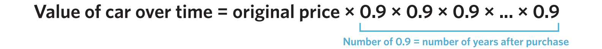

  - Determine the value of a $54000 car after three years using $\$54000×{\left(0.9\right)}^{3}$.

$39366
  - Rounded to the nearest dollar, determine the value of the car when it is 10 years old.

$18829
  - Will the value of the car ever reach zero?

No. (You will get very small fractions of a dollar, but it will never become zero).
- A cube has sides of length 6 cm.
  - Calculate the volume of the cube.

216 cm³
  - Each side of the cube is increased by 10%. Find the new volume of the cube.

287.496 cm³
  - Work out the percentage increase in the volume of the cube.

33.1% increase
  - Would your answer to part c change if the original side lengths were different?

No

The Unitary Method for Percentages

- Review
- Divide to find the value of 1 of a quantity.
- 5 apples cost $20,  how much is 1 apple? | - 12 oranges cost $60,  how much is 1 orange?
- 5 apples cost $2,  how much is 1 apple? | - $60 can buy 15 oranges,  how much is 1 orange?

- Use the unitary method to find a new value.
- 6 bananas are $30.  How much does 8 bananas cost? | - $40 can buy 80 lollies.  How much does 55 lollies cost?

- Unitary Method
The unitary method for percentages involves finding a new percentage, given a particular percentage.
- Identify the percentage the given value represents.
- Divide to find 1%.
- Multiply to find the percentage you need (100% for the original).

- Leave numbers as exact fractions; do not round until the very last step.

- Example Solve percentage problems using the unitary method.
8% of an amount of money is $70. What is the full amount?
$$8\% = \$70$$  $$÷8 ÷8$$  $$1\%=\frac{\$70}{8}$$  $$×100 ×100$$  $$100\%=\$875$$  The full amount is $875 | $70 represents …………% of the original.  We divide 8% by …… to find 1%.  We multiply 1% by ……… to find 100%, which is the ……… amount.

- Guided Practice
- 12% of a number is 40.  What is the full amount? | - 11% of a number is $77.  What is the full amount?
  ………% | $$=$$ | 40
  1% | $$=$$ | ………
  ………% | $$=$$ | ………
- 17% of a number is 51.  What is 25%? | - 78% of a number is $312.  What is 120%?

- Key Ideas
- The unitary method …………… to find 1% first, then ……………… to find another amount.

Foundation
- Complete the table.
- 90% of a number is 180. What is the number?  $$90\%=180 \\ 10\%=20$$ $100\%=$ ………  200 | - 90% of a number is 450. What is the number?  $90\%=450$  $10\%=$ ………  $100\%=$ ………  500 | - 90% of a number is 72. What is the number?  80
- 80% of a number is 720. What is the number?  900 | - 80% of a number is 120. What is the number?  150 | - 60% of a number is 120. What is the number?  200
- 20% of a number is 120. What is the number?  600 | - 70% of a number is 490. What is the number?  700 | - 70% of a number is 245. What is the number?  350
- 50% of a number is 160. What is the number?  320 | - 25% of a number is 160. What is the number?  640 | - 85% of a number is 170. What is the number?  200

- Find the amount required for each of the following.
- 3% is 27. Find the full amount.  900 | - 5% is 40. Find the full amount.  800
  3% | $$=$$
  $1\%$ | $$=$$
  $100\%$ | $$=$$
  ……% | $$=$$
  $1\%$ | $$=$$
  ……% | $$=$$
- 12% is $132. Find the full amount.  1100 | - 60% is 300. Find the full amount.  500
- 6% is $36. Find 20%. | - 15% is $45. Find 80%.
  6% | $$=$$
  $1\%$ | $$=$$
  $20\%$ | $$=$$
  ……% | $$=$$
  $1\%$ | $$=$$
  ……% | $$=$$
120  - 40% is $200. Find 3%.  15 | 240  - 25% is 75. Find 7%.  21

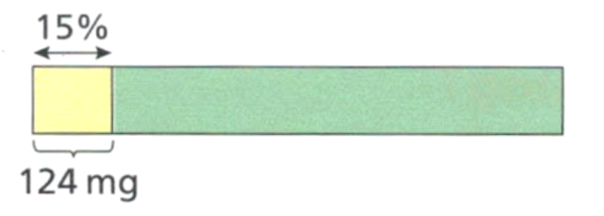
- A cup of milk contains 124 mg of calcium. This is roughly 15% of an adult’s recommended daily intake of calcium.

Using the above information, what is the recommended daily intake of calcium for an adult?

$826.\dot{6}$ mg
- A bottle is 13% full and currently holds 143 mL. What is the capacity of the bottle?

1100 mL

Development
These questions don’t require finding 1% first. Instead, it would be easier to work with 10% as ‘unit’.
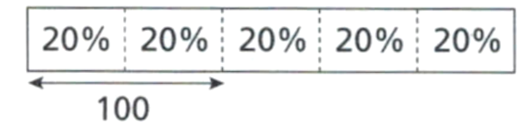
- 40% of a number is 100.

Work out:
- 10% of the number  40% = 100  $$÷4 ÷4$$  10% = ………  25 | - 5% of the number  12.5 | - 60% of the number  150 | - 100% of the number  250

- 10% of an amount of money is $60, how much is:
- 100% of that amount?  $600 | - 150% of that amount?  $900 | - 15% of that amount?  $90

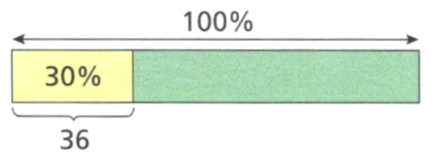
- 30% of a number is 36.

Work out:
- 10% of the number  12 | - 5% of the number  6 | - 40% of the number  48
- 60% of the number  72 | - 100% of the number  120 | - 140% of the number  168

- 120% of a number is 96. Work out:
- 10% of the number  8 | - 20% of the number  16 | - 35% of the number  28 | - 100% of the number  80
- If 40% of a number is 32, find:
- 10% of the number  8 | - 5% of the number  4 | - 15% of the number  12
- 120% of the number  96 | - 200% of the number  160 | - 75% of the number  60

- What is the mass if  120% of the mass is 720 kg?  600 kg | - What is the volume if  175% of the volume is 120 L?  68.57 L

- 35% of students come to school by car. If 559 students do not come to school by car, how many students are at the school?

860
- 80% of Mr Ding’s students regularly do their homework.
If 17 students do not regularly do their homework, how many students does Mr Ding teach?

85
- 40% of workers for a large construction company prefer to have an early lunch,
25% of workers prefer to work through lunch and leave earlier.
All other workers prefer a late lunch.
If 70 workers prefer a late lunch, how many workers are employed by the company?

200

Unitary Method for Reverse Percentage Problems

- Review
- Convert percentage increase to the percentage multiplier
- Increasing by 20% is finding ………% of the original. | - Increasing by 7% is finding  ………% of the original.
- Increasing by 35% is finding ………% of the original. | - Increasing by 150% is finding ………% of the original.

- Convert percentage decrease to the percentage multiplier
- Decreasing by 20% is finding ………% of the original. | - Decreasing by 7% is finding  ………% of the original.
- Decreasing by 35% is finding ………% of the original. | - Decreasing by 99% is finding ………% of the original.

- Convert percentage decrease to the percentage multiplier
- 17% of a number is 50.  What is the full amount? | - 110% of a number is 28.  What was the original amount?
- 88% of a number is 90.  What is 42%? | - 45.5% of a number is 89  What is 67%?

- Identifying what Percentage a Value Represents
When a problem tells you a value after a percentage change, that value represents a percentage of the original. You must identify this percentage before solving the problem.
The original amount is always 100%
After an increase of $x$%, the new value is $\left(100+x\right)\%$ of the original.
After a decrease of $x$%, the new value is $\left(100-x\right)\%$ of the original.
Words like ‘increased by, decreased by’ represent the change, $x\%.$

- Interpret the percentage a value represents
Identify the percentage that the value represents.
- After a 25% increase, the price is $60.  $60 represents ………% of the original. | - After a 25% decrease, the price is $60.  $60 represents ………% of the original.
- After a 15% increase, the value is 60.  60 represents ………% of the original. | - After a 40% increase, the value is 60.  60 represents ………% of the original.
- After a 15% decrease, the population decreased by 60.  60 represents ………% of the original. | - After an 85% increase, the value increased by 60.  60 represents ………% of the original.
- After a 12% increase, the cost is $60.  $60 represents ………% of the original. | - After a 12% reduction, the number of items left is 60.  60 represents ………% of the original.

- Key Ideas
- The original amount is always ………%
- After an increase of $x$%, the final value represents ($100$ … $x$) % of the original.
- After a decrease of $x\%$, the final value represents ($100$ … $x$) % of the original.
- Words like ‘increased by, decreased by’ refer to the change in value, ………%

- Unitary Method
- Identify the percentage the given value represents.
- Divide to find 1%.
- Multiply to find the percentage you need (100% for the original).

- Leave numbers as exact fractions; do not round until the very last step.

- Example Solve reverse percentages problems using the unitary method.
After a 15% pay increase, Emma earns $690 a week. What did she earn before the pay rise?
$$115\% = \$690$$  $$÷115 ÷115$$  $$1\%=\frac{\$690}{115}$$  $$×100 ×100$$  $$100\%=\$600$$  She earned $600 before the pay rise. | After a 15% increase, $690 represents …………% of the original.  We divide 115% by …… to find 1%.  We multiply 1% by ……… to find 100%, which is the ………… pay.

- Guided Practice
- After a 20% increase, the price of an item is $180. Find the original price. | - After a 30% decrease, the price of an item is $140. Find the original price.
  ………% | $$=$$ | $180
  1% | $$=$$ | ………
  ………% | $$=$$ | ………
- After a 35% increase, there are now 2100 people in a village. What was the original population? | - After an 85% decrease, the number of trees in a forest decreased by 2006. How many trees were in the forest originally?

Foundation

- After a 10% increase, a book costs $55. What was the original price?  $$\$50$$ | - After a 25% decrease, a shirt costs $60. What was the original price?  $$\$80$$
  ………% | $$=$$ | $55
  1% | $$=$$ | ………
  ………% | $$=$$ | ………
- After a 50% increase, there are 180 students in a club. How many were there originally?  $$120$$ | - After a 15% pay rise, Marcus earns $920 per week. What did he earn before?  $$\$800$$
- After a 12% decrease, the population of a town is 2200. What was the original population?  $$2500$$ | - A laptop costs $756 after a 30% increase. Find the original price.  $$\$581.54$$
- After losing 35% of its water, a tank contains 260 litres. How much water did it originally contain?  $$400 L$$ | - After an 8% increase, a monthly rent is $837. What was the rent before the increase?  $$\$775$$
- After a 17.5% increase, the price of a meal is $32.90. Find the original price.  $$\$28$$ | - A population decreased by 12.5% to 3500. What was the original population?  $$4000$$

Unitary Method for Financial Problems

- Review
- Solve percentage problems using the unitary method
- After a 15% increase, the value is $230. Find the original. | - After a 40% decrease, the value is $120. Find the original.

- Identify whether each word represents increase or decrease
- Surcharge  increase | decrease | - Depreciation  increase | decrease | - Mark-up  increase | decrease
- % off  increase | decrease | - Loss  increase | decrease | - Inflation  increase | decrease
- Profit  increase | decrease | - Appreciation  increase | decrease | - Mark-down  increase | decrease

- Interpret the percentage a value represents
Identify the percentage that the value represents.
- After a 25% surcharge, the bill is $60.  $60 represents ………% of the original. | - After 25% depreciation, the price is $60.  $60 represents ………% of the original.
- After a 25% loss, the value is 60.  60 represents ………% of the original. | - After a 25% loss, the value decreased by $60.  $60 represents ………% of the original.
- After a 25% discount, the price is $60.  60 represents ………% of the original. | - After a 25% discount, Amy saved $60.  $60 represents ………% of the original.
- After a 25% mark-up, the price is $60.  $60 represents ………% of the original. | - A 25% inflation caused the price to increase by $60.  $60 represents ………% of the original.
- A sale had a skirt 25% off, and the price dropped by $60.  $60 represents ………% of the original. | - A skirt appreciated by 25%, its value rose to $60.  $60 represents ………% of the original.

- Unitary Method
- Identify the percentage the given value represents.
- Divide to find 1%.
- Multiply to find the percentage you need (100% for the original).

- Leave numbers as exact fractions; do not round until the very last step.

- Example Solve percentages financial problems with the unitary method.
A pair of shoes costs $120 after a 20% discount. What was the original price?
$$80\% = \$120$$  $$÷80 ÷80$$  $$1\%=\frac{\$120}{80}$$  $$×100 ×100$$  $$100\%=\$150$$  The original price was $150. | ‘discount’ means increase | decrease  After a 20% discount, $120 represents ………% of the original, because $100\%-$ ……%  The original price, $150, is larger than $120 because discounts make prices …………………

- Guided Practice
- A jacket costs $84 after a 30% discount. Find the original price. | - A restaurant meal costs $57.50 after a 15% surcharge. What was the original price?
  ………% | $$=$$ | $84
  1% | $$=$$ | ………
  ………% | $$=$$ | ………
- A painting is worth $1560 after appreciating by 15%. Find the original price. | - A car is worth $44 000 after depreciating by 20%. Find the original value.

- Key Ideas
- Discount, % off, mark-down, depreciation, and loss all mean percentage ……………
- Mark-up, surcharge, inflation, appreciation, and profit all mean percentage ……………

Foundation
- Determine the percentage of the original.
- A book is marked up by 20%.  Retail price is ……% of the cost price  120% | - A bag of apples was marked up by 30%.  Retail price is ……% of the cost price  130%
- A yoga mat is discounted by 40%.  Discounted price is ……% of the original.  60% | - A hairdresser discounts services by 10%.  Discounted price is ……% of the original.  90%
- A yoga mat is 65% off.  New price is ……% of the original.  35% | - A meal includes a 15% surcharge.  New price is ……% of the original.  115%

- The price of an item has marked up by 10% to $132. What is the original price?  $120 | - The price after a 12% markup is $720. What was the original price?  $642.86
  ………% | $$=$$ | $132
  1% | $$=$$ | ………
  100% | $$=$$ | ………
- A necklace in a jewellery store has been discounted by 20% to $240.  What was the original price?  $300 | - A restaurant bill comes to $38.50. This includes a 10% public holiday surcharge. What is the cost on a normal day?  $35
- Brian drinks 40% of the water from his drink bottle and there is 300 mL left.  How much water was in the drink bottle to begin with?  500 mL | - A travel agency reduces the prices of their holidays by 30%.  Calculate the original price if the discounted price is $2800.  $4000

Development
- Calculate the cost price, rounding to the nearest cent where relevant.
- Find the original price of a pack of batteries that is discounted by 30%, if the discounted price is $14.  $20 | - Find the original price of a herbal tea pack after a discount of 20%, if the discounted price is $2.40.  $3
- Find the cost price of a shampoo bottle that is marked up by 40%, if the retail price is $5.  $3.57 | - Find the cost price of a bag of dog food that is marked up by 30%, if the retail price is $19.23.  $14.79
- Find the original price of a pair of jeans that is discounted by 20%, if the discounted price is $31.96.  $39.95 | - Find the ​cost ​price ​of ​a ​roll ​of ​​tape​ that ​is​marked​ up ​by​ 60%,​ if ​the​ retail​ price ​is $2.80.  $1.75

- Rhys is solving this problem:
After a 12% pay rise, a worker earns $168 a day. What did the worker earn before the pay rise?
- Work out the worker’s original pay.  $150 | - Rhys tried to solve the problem by finding 88% of $168. Is he correct?  No. You cannot reverse a 12% increase by decreasing by 12%

- Gary’s salary increases from $22 500 to $23 400.
  - Work out the percentage increase in Gary’s salary.

4%
  - Gary and Beca both get a pay rise of the same percentage.
Beca's salary increases to $23 920.
Use your answer to part a to work out Beca's salary before her pay increase.

$23 000

Goods and Services Tax (GST)

- Review
- Use the unitary method to solve percentages problems.
- After a 10% increase, the value is $25. Find the original value. | - 10% of a number is $25.  Find the full amount.
- After a 10% increase, the value increased by $25. Find the original value. | - After a 10% increase, the value increased by $25. Find the final increased value.
- Increase $25 by 10%. | - After a 10% increase, the value is $25. Find the increase.

- Identify the operation.
- $10\%$ $×$…… $=100\%$ | - $110\%$ $÷$…… $=10\%$ | - $100\%$……… $=10\%$
- $10\%$……… $=110\%$ | - $110\%$ ……… $=10\%$ | - $10\%$……… $=100\%$

- Goods and Services Tax (GST)
Term | Percentage | Meaning
Pre-GST price  Price before GST  Price without GST  Original Price | 100% of original | Price before tax is added
GST  GST Payable | 10% of original | The tax part only
GST-inclusive price  Final Price | 110% of original | Total price including tax
In Australian shops, all displayed prices include GST.
This means you are always paying 110% of the pre-GST price.
GST calculations are used all the time by businesses to set prices and pay the government.

- Interpret language of GST.
What percentage does each value represent?
- The GST-inclusive price is $60.  $60 represents ………% of the original. | - The GST payable is $60.  $60 represents ………% of the original.
- The price without GST is $60.  $60 represents ………% of the original. | - The item is $60 in the shop.  $60 represents ………% of the original.
- The pre-GST price is $60.  $60 represents ………% of the original. | - The GST is $60.  $60 represents ………% of the original.
- The final price is $60  $60 represents ………% of the original. | - The price without GST is $60  $60 represents ………% of the original.

- Unitary Method
- Identify the percentage the given value represents.
- Divide to find 10%.
- Multiply to find the percentage you need.

- We divide to find 10% because 10% is the smallest ‘unit’ you work with for GST.

- Example Solve GST problems.
A television costs $500 in a shop. What is the price before GST?
$$110\% = \$500$$  $$÷11 ÷11$$  $$10\%=\frac{\$500}{11}$$  $$×10 ×10$$  $$100\%=\$454.5454…$$  Price before GST is $454.55 | Shop prices include GST, so $500 represents ………% of the pre-GST price.  We divide 110% by 11 to find ……%.  We multiply by …… to find 100%.  The pre-GST price is always ………… than the final price.
Mr Ding buys a milk tea from a store. He was charged $7.95 in total.
How much was the GST?
$$110\% = \$7.95$$  $$÷11 ÷11$$  $$10\%=\frac{\$7.95}{11}$$  $$=0.7227…$$  He was charged $0.72. | $7.95 was what he paid for, so it represents ………% of the original price.  The question asked for the GST, which is ………%. So, we did not need to multiply after finding 10%

- Guided Practice
- A phone costs $990 in a shop.  Find the pre-GST price. | - A meal costs $44 in a restaurant.  How much GST is included?
- The GST on a couch is $85.  What is the GST-inclusive price? | - A plumber charges $264 without GST.  How much GST should he charge?

Foundation
- If the GST payable is $8:
- Find the original price without GST.  $80 | - Find the price including GST.  $88
  10% | $$=$$ | $8
  100% | $$=$$
  10% | $$=$$ | $8
  110% | $$=$$

- If the GST included price is $99:
- Calculate the GST payable.  $9 | - Calculate the original price.  $90
  ……% | $$=$$ | $99
  ……% | $$=$$
  $$=$$
  $$=$$

- The cost of a lounge suite is $990 including GST.
- Calculate the GST payable.  $90 | - Calculate the pre-GST price  $900
- For each of the following items, the cost including GST is given.
Calculate the cost before GST was added.
- A plane ticket costing $715.  $650 | - A lawnmower costing $495.  $450
- A meal costing $18.  $16.36 | - A phone costing $2400.  $2181.82

Development
- Read these questions carefully to determine what you are given and what you need to find.
- A laptop costs $440 before GST. Calculate the price including GST.  $$\$484$$ | - A tablet's price including GST is $627. Find the original price before GST.  $$\$570$$
- A phone costs $935 after GST is added. Calculate the GST amount.  $$\$85$$ | - The GST on a laptop is $44. Find the original price.  $$\$440$$
- A laptop costs $484 including GST. Determine the price before GST.  $$\$440$$ | - The GST on a camera is $72. Find the original price.  $$\$720$$
- A monitor costs $396 including GST. Determine the price before GST.  $$\$360$$ | - The final price on headphones are $308. Calculate the original price.  $$\$280$$
- A mouse costs $55 after GST is added. Calculate the GST amount.  $$\$5$$ | - A scanner costs $520 before GST. Calculate the price including GST.  $$\$572$$

- A plumber’s quote for installing a dishwasher is $264, including the GST.
- Use the unitary method to calculate the GST payable.  $24 | - Divide $264 by 11; does this give the same answer as part a?  yes
- Calculate the pre-GST price for installing the dishwasher.  $240 | - Divide $264 by 1.1; does this give the same answer as part c?  yes
- GST Problem Shortcuts
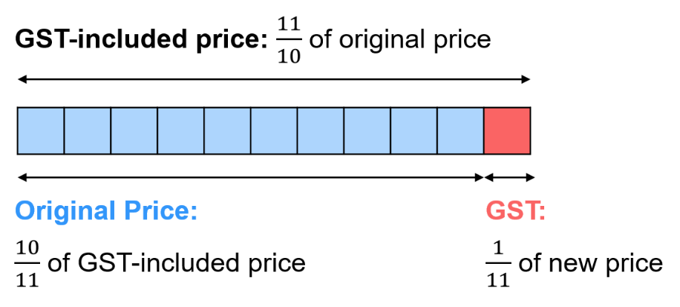

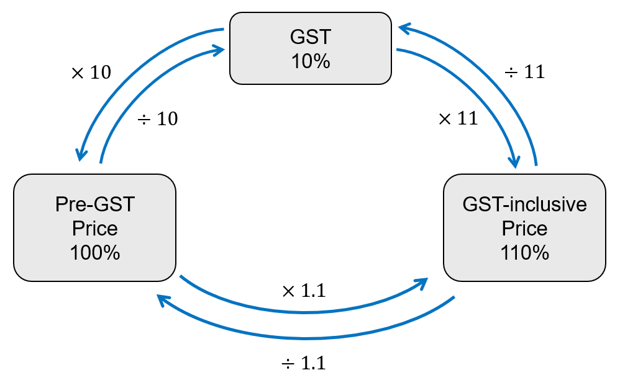

- These are GST-inclusive prices. Find GST payable and pre-GST price.
- $616  GST payable:  $616÷11=$  $56  Pre-GST price:  $616÷1.1=$  $560 | - $1067  GST payable:  $97  Pre-GST price:  $970 | - $8679  GST payable:  $789  Pre-GST price:  $7890 | - $108.57  GST payable:  $9.87  Pre-GST price:  $98.70
- Complete this table.
Original Price  (no GST) | 10% GST Payable | Price  (110% of original)
$599 | $59.90 | $658.90
$125 | $12.50
$680 | $68 | $748
$700 | $70 | $770
$850 | $85 | $935
$600 | $60 | $660
$650 | $65 | $715
$789 | $78.90 | $867.90
$270 | $27 | $297
$892 | $89.20 | $981.20
$661.50 | $66.15 | $727.65
$645 | $64.50 | $709.50
$518.18 | $51.82 | $570
$27.74 | $2.77 | $30.51

Mastery
- Aimee has two quotes for repairs on her car. The first is a pre-GST price of $2450.
The second is $2680 including GST. Which quote is cheaper and by how much?

Second quote cheaper by $15
- The GST is also called a ‘value-added tax’ (VAT).
Since a tax is only meant for citizens of a country, if you go travelling in another country you can get the tax you pay refunded at the airport or at special tourist stores, called ‘duty-free’.
Unless the VAT is 10%, you cannot use the shortcuts used for Australian GST.
Use the unitary method to answer these questions:
  - The GST in Australia is 10%.
If a tourist paid $1200 for an iPhone, how much GST would they get refunded?

$109.09
  - The VAT in Thailand is 7%. Mr Ding bought his mum a scarf for ฿4800.
How much VAT would he get refunded?

฿314.02
  - The VAT in Japan is 10%. Mr Ding bought some soft toys for ¥24 000.
How much VAT would he get refunded?

¥2181.82
  - The VAT in New Zealand is 15%. A tourist was refunded $90.
What was the VAT-inclusive value of the merchandise they bought?

$690
  - The VAT in the UK is 20%. A tourist got refunded £144 for a laptop they bought.
What was the VAT-inclusive value of the laptop?

$864

Mixed Practice

Foundation
- Fill in the table. You may use a calculator. The method for finding each unknown is given.
Original Amount  Unitary method | Percentage Change  $$\frac{Change}{Original}×100$$ | New Amount  $$×Decimal$$ | Change  $$Final-original$$
50 | $$+20\%$$ | $50×1.2=$  60 | 10
60 | $$+20\%$$ | 72 | 12
72 | $$+20\%$$ | 86.4 | 14.4
72 | $$-20\%$$ | 57.6 | $-14.4$
72 | $-25\%$ | 54 | $-18$
72 | $+35.41\dot{6}$% | 97.5 | 25.5
45 | $$+20\%$$ | 54 | 9
67.5 | $$-20\%$$ | 54 | $-13.5$
54 | 0% | 54 | 0
54 | 100% | 108 | $$+54$$
135 | $-20\%$ | 108 | $$-27$$
81 | $+33.\dot{3}\%$ | 108 | $$+27$$
96 | $+12.5\%$ | 108 | $-12$
$78.72$ | $$+25\%$$ | 98.40 | 19.68
98.4 | $-20\%$ | 78.72 | $$-19.68$$
85.6 | $+20\%$ | 102.72 | $$+17.12$$

- Complete the table. Round your answer to 2 decimal places.
Cost Price  Unitary method | Selling Price  $×Decimal$ | Percentage Change  $$\frac{Final-Original}{Original}×100$$
$30 | $30×0.8=24$ | 20% loss
$85 | $69.70 | 18% discount
$65 | $75 | $$\frac{75-65}{65}×100=15.38\%$$
$700 | $665 | 5% decrease
$$120\%=30 \\ 1\%=0.25 \\ 100\%=25$$ | $30 | 20% profit
$80 | $100 | 25% mark-up
$60 | $75 | 25% inflation
$40 | $50 | 25% increase
$166.67 | $100 | 40% off
$550 | $649 | 18% surcharge
$50 | $40 | 20% decrease
$64 | $80 | 25% profit
$100 | $80 | 20% reduction
$200 | $10 | 95% decrease
$75 | $97.50 | 30% profit
$500 | $350 | 30% loss

Development

- Calculate 15% of 60  9 | - Express 15 as a percentage of 60  25% | - 15% of a number is 60.  What is the number?  400
- Increase 60 by 15%  69 | - Decrease 60 by 15%  51 | - A number is increased by 15% to 60. What is the number?  52.17
- A number is decreased by 15% to 60.  What is the number?  70.59 | - 15 increased to 60.  What is the percentage change?  300% increase | - 60 decreased to 15.  What is the percentage change?  75% decrease
- 60 decreased by 15.  What is the percentage change?  25% decrease | - 15 increased by 60.  What is the percentage change?  400% increase | - 60 increased by 15. What is the percentage change?  25% increase

- A jacket originally costs $80.  Its price increased by 20%.  What is its new price?  $96 | - A jacket originally costs $80.  Its price was reduced to $20.  What was the percentage discount?  75% discount
- A jacket originally costs $80.  Its price decreased by $20.  What is the percentage discount?  25% discount | - A jacket originally costs $80.  Its selling for 20% off.  What is the sale price?  $64
- Find the amount required for each of the following.
- A bottle of shampoo is labelled "25% extra free". The bottle contains 250 mL of shampoo. Work out how much shampoo a normal-sized bottle contains.  200 mL | - Abby’s restaurant bill comes to $38.50. This includes a 10% service charge. Calculate the cost of the meal before the service charge was added.  $35
- A sunflower is 180 cm tall. This is an increase of 5% on its height a week earlier. What was the height last week? Answer to 1 decimal place.  171.4 cm | - Emily sells her car for $3500. She makes a 12% profit on the price she paid. How much did Emily pay for the car?  $3125
- After an 8% pay rise, Faith earns $91.80 a week. How much was Faith paid before the pay rise?  $85 | - The cost of a theatre ticket is reduced by 5% to $42.75. What was the cost before the decrease?  $45
- Because of a 10% increase, the price of Chloe's train ticket increases by $2.30. Work out the price before the increase.  $23 | - In a sale, the price of a fridge is reduced by $40\%$. The fridge now costs $279. Work out the original price of the fridge.  $465
- A pair of jeans cost $59.50 in a "15% off everything" sale. How much did the jeans cost before the sale?  $70 | - A car dealer makes a 25% profit when she sells a car for $4000. How much did she pay for the car?  $3200

- Solve these percentage problems.
- A computer costs $800 before GST of 10% is added. Work out the price of the computer after GST is added.  $880 | - A washing machine costs $450. Work out the price of the washing machine after a 20% discount.  $360
- Beca scores 68 out of 80 in a Science test. Express her score as a percentage.  85% | - Marta scored 84 marks in a test. As a percentage, Marta scored 70%. Work out the total number of marks in the test.  120
- In a school, 15% of the students wear glasses. If 63 students wear glasses, how many students are in the school?  433 students | - Jackson buys a scooter. He pays $300 including GST at 10%. Work out the price of the scooter before GST is added.  $272.73
- A necklace costs $23. In a sale, the price is reduced by 12%. What is the sale price of the necklace?  $20.24 | - In a survey, the population of a village was 4752. One year later, the population has increased by 3%. Find the new population to the nearest integer.  4895
- Flo scored 56 out of 80 in a Maths test. Ed scored 64 out of 92 in a different test. Who did better?  Flo | - Seb buys a bike for $245 and sells it for $380. Work out the percentage profit.  55.1%
- In a sale, the price of a dress is reduced from $26 to $20.80. Work out the percentage discount.  20% discount | - A ball is dropped from a height of 150cm. After each bounce, it reaches a height 20% lower than previously. What height does it reach after the fourth bounce?  61.44 cm
- In a sale, all prices in a shop are reduced by 10%. Later, the shop is offering an extra 25% off sale prices. Work out the price of a pair of shoes that cost $90 before the sale.  $60.75 | - Ms Harris sold a house for $462 000, making a 65% profit on the amount she paid for the house. How much profit did she make?  $182 000
- A shopkeeper wants to sell an item for $500, including GST. How much GST is he charging his customers?  $45.45 | - Samantha went shopping and bought a new bike for $750. How much GST did she pay?  $68.18
- In a sale, the price of a laptop is reduced by 25%. A week later, the price is reduced by a further 15%. The final price is $586.50. Work out the original price of the before the sale.  $920 | - The value of an investor's shares dropped by 18% to $30 750 in a financial crash. What was the value of the shares before the crash?  $37500
- Bev rolls a die and it lands on six 35% of the time. The dice lands on six 147 times. How many times did Bev roll the dice?  420 | - Darius has been saving to buy a laptop. The laptop originally cost $800 but has increased in price by 25%. Darius has saved $900. How much more does he need to save?  $100
- A shoe store is running a 20% off storewide sale.
- How much would you pay for a pair of sneakers originally priced at $56.50?  $45.20 | - Mr Ding pays $48.80 for a pair of shoes. What was the original price?  $61
- Another shop is offering one quarter off the price storewide. Which is the better deal, and why?  one-quarter as that’s 25% | - You have $500 to spend. How many pairs of shoes, costing $96 before the price reduction, can you buy?  6 pairs

- A loaf of bread costs 89c. The price increases by 22% due to inflation.  What is the new price? Answer in dollars.  $1.09 | - The price of a loaf of bread increases from 89c to $1.20. What is the change as a percentage? Round to 1 d.p.  34.8%
- A loaf of bread cost 89c five years ago. This price increases by 6% every year. How much does it cost now, to the nearest cent?  $1.58 | - A shop marks down a loaf of bread to 89c in a 30% off sale. What did it cost originally?  $1.27

Mastery
- HSC Standard 2 Sample Question Band 4
A golf shop is having a Boxing Day sale.
  - What is the percentage discount on a putter which is reduced from $120 to $102?

15%
  - The same discount applies storewide.
What discount amount is applicable to a box of golf balls whose original price was $25?

$3.75
  - What is the sale price of a golf bag which originally cost $160?

$136
- NAPLAN A+
Lucia is saving her money to buy a jet ski.
After 3 months, she had saved 40% of the cost of the jet ski.
After 5 months, she had saved another $1200 and now had 60% of the cost of the jet ski.
How much does the jet ski cost?

$1200 represents 20%
So 10% = $600, 100% = $6000
Jet ski costs $6000
- NAPLAN A+
Harrison was saving his money to buy a cricket bat.
After 1 month, he had saved 45% of the bat's cost.
After 2 months, he had saved another $90 and now had 75% of the bat's cost.
How much does the bat cost?

$90 represents 30%
So 10% = $30, 100% = $300
Bat costs $300
- 2023 HSC Standard 1
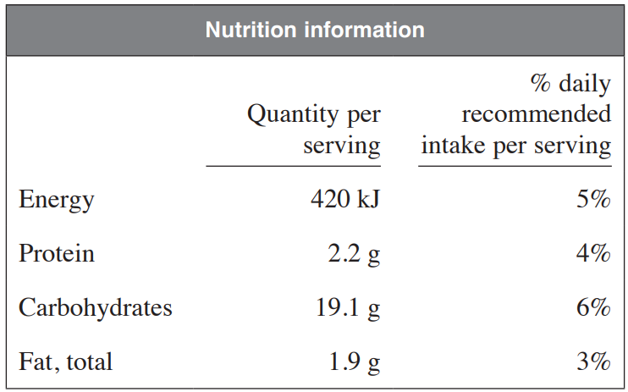
The nutrition label for a food item is shown. Based on the information on this label, what is the daily recommended intake of carbohydrates, to the nearest gram?

6% is 19.1
1% is $\frac{19.1}{6}$
100% is 318 g
Total recommended daily intake is 318 g
- 2004 HSC Standard 2 Band 4
Rita purchased a camera for $880 while on holidays in Australia. This price included 10% GST. When she left Australia she received a refund of the GST.
What was Rita’s refund?

110% is $880
10% is $80
Refund of $80
- 2018 HSC Standard 2 Band 5
To determine the retail price of an item, a shop owner increases its cost price by 30%. In a sale, the retails price is reduced by 30% to give the sale price.
How does the sale price compare to the cost price?
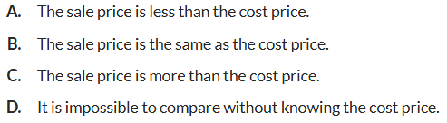

Let cost of item be $x$
$$x×1.3×0.7$$
$$=x×0.91$$
So overall it is a 9% decrease
A

- 2010 HSC Standard 2 Band 5
A new phone was purchase for $725 which included 10% GST.
What was the price of the phone without GST, correct to the nearest cent?

110% = $725
10% = 65.9090…
100% = $659.09
- 2023 HSC Standard 2 Band 5
A receipt from a supermarket shows a total of $124.87. The GST shown on the receipt is $3.86.
GST, at a rate of 10%, is only charged on some items.
What was the value of the items which did NOT have GST charged?

$3.86 represents 10% of GST items
Cost of GST-inclusive items $3.86 $×$ 11 = $42.46
Value of goods without GST = $124.87 − $42.46 = $82.41
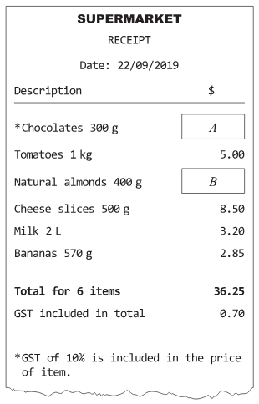
- 2019 HSC Standard 2 Band 5
Part of a supermarket receipt is shown.
Determine the missing values, $A$ and $B$.

Only chocolates has GST charged, so 0.70 is 10%, so the cost of chocolates is 110%, $7.70.
To find almond cost, subtract all other items from total.
A = $7.70; B = $9
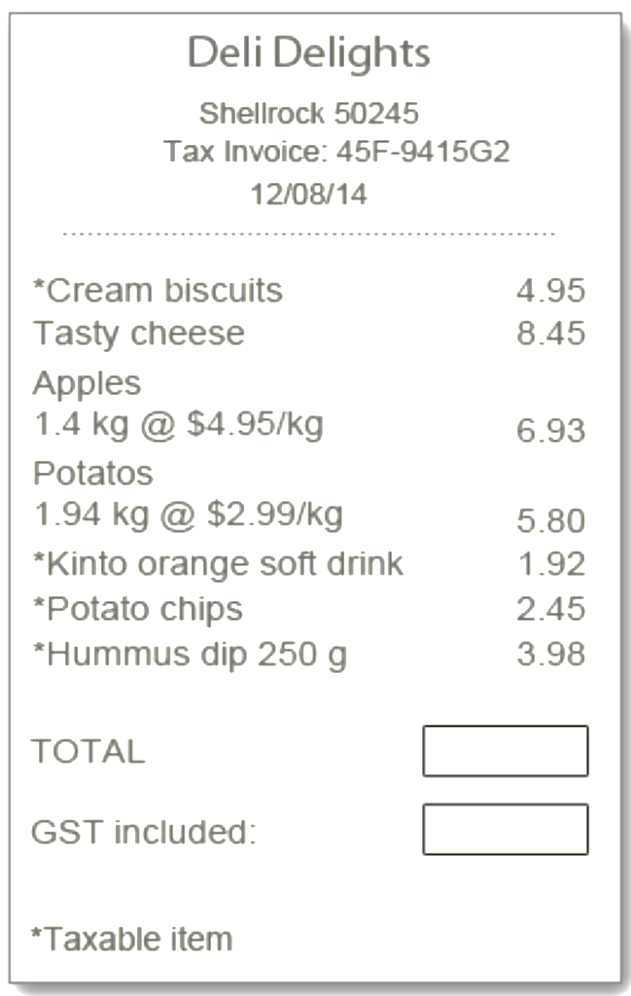
- Not all items in a supermarket attract GST.
Read the receipt carefully and answer the questions.
  - Calculate the total cost.
Total = $34.48
  - Highlight the prices that include GST.
  - Complete the calculation to find the GST included
in the price of biscuits:
GST (biscuits) = $\$4.95÷11$
$=$ ………………
  - Therefore, calculate the total GST included.

Find the GST included in orange soft drink, potato chips, and hummus, then add (don’t forget to include GST from the biscuits)
GST = $1.21

- 2023 HSC Standard 2 Band 5
An item is discounted by 30% and then a further discount of 20% is applied to the reduced price. What is the total percentage discount?

Let cost of item be $x$
$$x×0.7×0.8$$
$$=x×0.56$$
The result is 56% of the original, so this is a 44% discount
- HSC Standard 2 Sample Question Band 5
A dress was on sale with 25% discount.
As a regular customer, Kate received a further 10% on the already discounted price.
What was the overall percentage discount Kate received?

Let cost of item be $x$
$$x×0.75×0.9$$
$$=x×0.675$$
The result is 67.5% of the original, so this is a 32.5% discount

Equations Method

- Algebraic Method for Solving Percentages Problems
The algebraic method involves forming an equation using the multiplier.
This method is for students who have mastered solving problems using the unitary method and confident with algebra.
The most challenging questions can be more easily solved using this method.

- Compare unitary method against equations & multiplier method
35% of a number is 84. Find the whole amount.
Unitary Method  $$35\% = 84 \\ ÷35 ÷35 \\ 1\%=\frac{84}{35} \\ ×100 ×100 \\ 100\%=240$$ |  | Algebraic Method  Let $x$ be the whole amount  $$0.35x=84 \\ ÷0.35 ÷0.35 \\ x=240$$
After a 22% discount, a dress costs $390. Find the original price.
Unitary Method  $$78\% = 390 \\ ÷35 ÷35 \\ 1\%=\frac{390}{78} \\ ×100 ×100 \\ 100\%=500$$ |  | Algebraic Method  Let $x$ be the whole amount  $$0.78x=390 \\ ÷0.78 ÷0.78 \\ x=500$$
Solve these questions using the equations method.
- 65% of a number is 90.  Find the whole amount. |  | - 120% of a number is 40.  Find the original amount.
- After a 30% discount, a pair of shorts costs $91. Find the original cost. |  | - After a 85% markup, a bag costs $159.10. Find the original amount.
- Example Solve problems involving repeated percentage change.
After a 10% increase then a 5% increase, a price is $231. Find the original price.
Let $x$ be the original price.  $$x×1.1×1.05=\$231 \\ x×1.155=\$231 \\ ÷1.155 ÷1.155 \\ x=\$200$$ | 10% increase gives multiplier ………  5% increase gives multiplier ………  We …………… the multipliers to get 1.155.  To find the original, we …………… the final by the combined multiplier.

- Guided Practice
- After a 20% increase then a 10% increase, the price is $264.  Find the original price. | - After a 15% discount then a 10% discount, the price is $306.  Find the original price.
- After a 30% increase and then a 30% decrease, the price of an item is $98.28.
Find the original price.

Foundation
- Instead of the unitary method, we can use equations to quickly solve for the unknown.
Worked Example | Explanation
90% of a number is 74.25.  Find the number.  $$x×0.9=74.25 \\ ÷0.9=÷0.9 \\ x=82.5$$ | Why did we multiply by 0.9?  To find ………%, we multiply by 0.9.  What does $x$ represent?  $x$ represents the ……………… amount.  Why did we divide both sides by 0.9 to find $x$?  The …………… operation of multiplication is division.

Find the number if:
- 80% of the number is 60  75 | - 75% of the number is 60  80 | - 12% of the number of 60  500
- 12.5% of a number is 60  480 | - $33$ $\frac{1}{3}$% of a number is 60  180 | - $66$ $\frac{2}{3}$% of a number is 60  90

- Read the example carefully and answer the questions.
Worked Example | Explanation
43% of a number is 11.18.  Find the value of 79%.  $$0.43x=11.18 \\ ÷0.43=÷0.43 \\ x=26 \\ 0.79x=20.54$$ | Why did we multiply by 0.43?  To find ………%, we multiply by 0.43.  What does $x$ represent?  $x$ represents the ……………… amount.  Why did we multiply $x$ by 0.79?  The question asked us to find ………%

- 6% of the total is 36.  Find 20%.  120 | - 15% of the total is 45.  Find 80%  240
- 40% of the total is 200.  Find 35%.  175 | - 25% of the total is 75.  Find 7%.  21

Development
- $100 is increased by 25%. What percentage decrease must be used to get back to $100?
An equation has been set up for you, where $d$ represents the decimal multiplier.
$100×1.25×d=100$

$d=0.8$, so 20% decrease

  - During a sale in a bookstore all travel guides are reduced from $30 by 20%.
What percentage increase is required to take the price back to $30?

25% increase
  - The cost of an item is reduced by 50%.
What percentage increase is required to return to its original price?

100% increase
  - The cost of an item is increased by 75%.
What percentage decrease is required to return to its original price?
Round to 2 decimal places.

42.86% decrease
  - The cost of an item is changed by $a$%, what do you need to multiply to return to the original cost?
$$\frac{1}{a}\%$$

  - The length of a rectangle is increased by 60% but its area remains the same.
By what percentage is the width decreased?

37.5%
  - The length of another rectangle is decreased by 25% and its area remains the same.
By what percentage is the width increased?

$33.3\dot{3}\%$

Mastery
- Work out the missing numbers.
125% | $166.\dot{6}$% | 14

- Find the missing number.
60 | 40 | 800
200 | 20 | 16

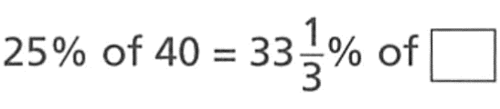
- Find the missing number:

30
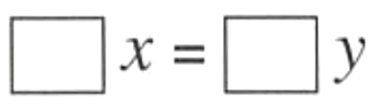
- Filipo is thinking of two numbers, $x$ and $y$.
He decreases $x$ by a quarter and increases $y$ by 20%. The new numbers are equal.
Write this information as an equation of the form:
If $y=60$, find the value of $x$.

96

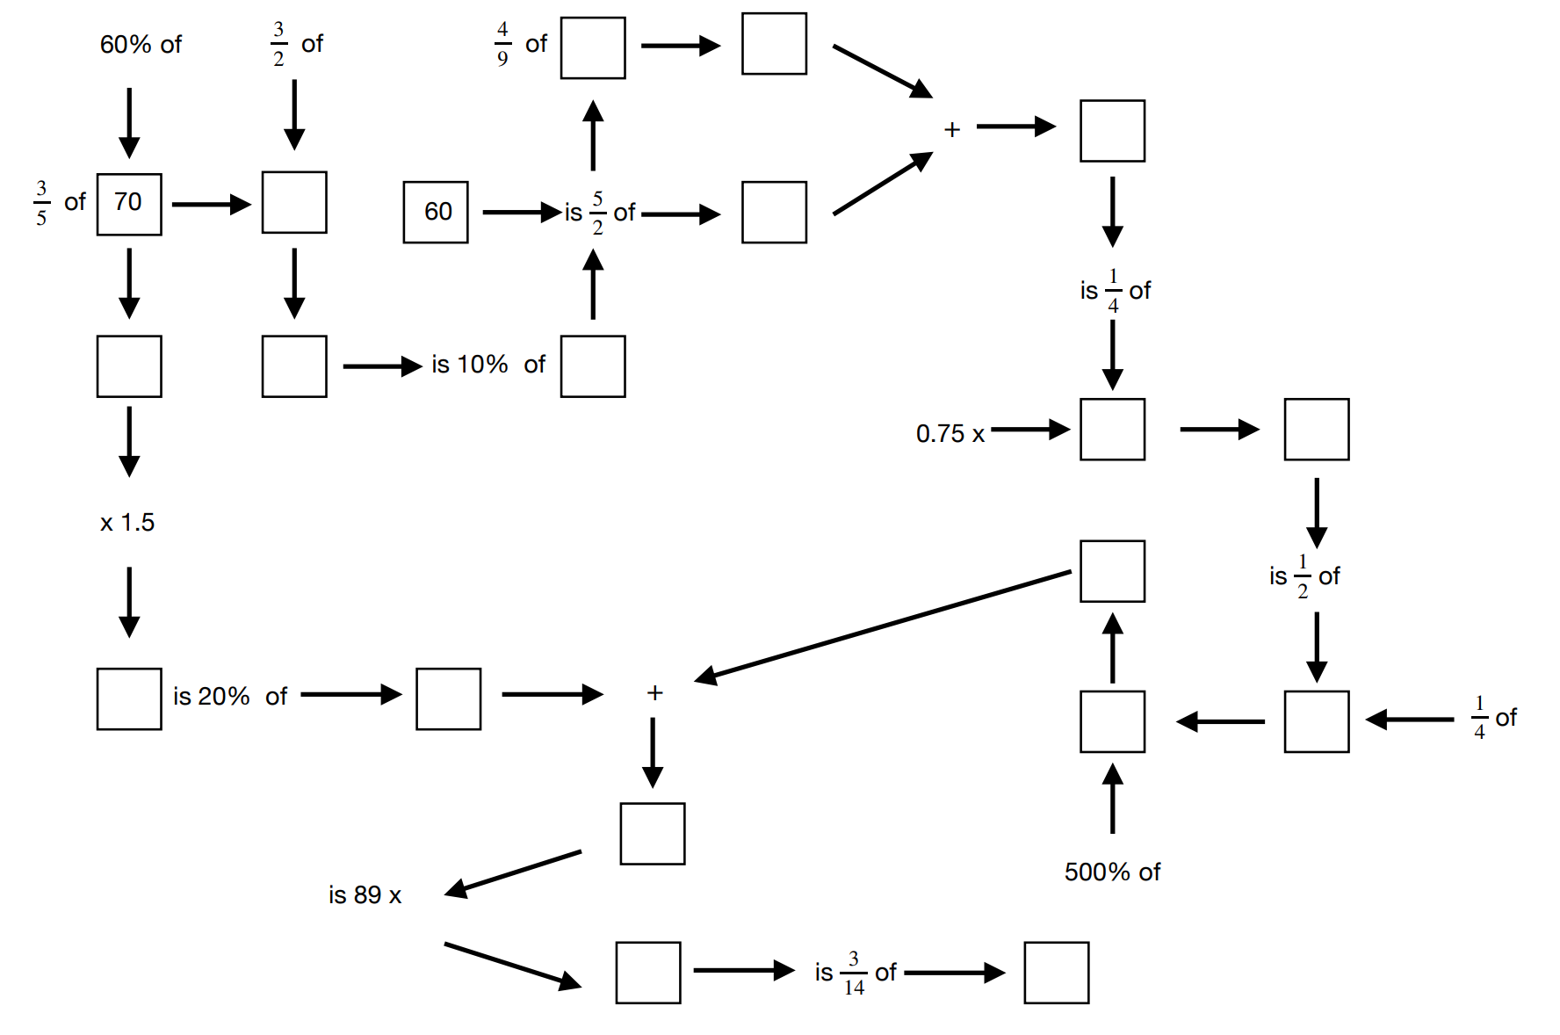
- Fill in the boxes.

